Analysis and Design Document

Student: Barabás Hunor

**Group: 30432**

Revision History

|  |  |  |  |
| --- | --- | --- | --- |
| **Date** | **Version** | **Description** | **Author** |
| <04/04/18> | <0.1> | First Iteration | Barabas Hunor |
|  |  |  |  |
|  |  |  |  |
|  |  |  |  |

Table of Contents

I.Project Specification 4

II.Elaboration – Iteration 1.1 4

1.Domain Model 4

2.Architectural Design 4

2.1Conceptual Architecture 4

2.2Package Design 4

2.3Component and Deployment Diagrams 4

III.Elaboration – Iteration 1.2 4

1.Design Model 4

1.1Dynamic Behavior 4

1.2Class Design 4

2.Data Model 4

3.Unit Testing 4

IV.Elaboration – Iteration 2 4

1.Architectural Design Refinement 4

2.Design Model Refinement 4

[Refine the UML class diagram by applying class design principles and GRASP; motivate your choices. Deliver the updated class diagrams.] 4

V.Construction and Transition 5

1.System Testing 5

2.Future improvements 5

VI.Bibliography 5

# Project Specification

Stock Market Simulator used to teach newbies to trade.

# Elaboration – Iteration 1.1

# Domain Model

The domain is somewhat similar to Assignment 1 in that it contains the models required to differentiate users: I'll have a Login model with information such as username, password and role. I'll have a User Model with basic user information and balance.

The difference will be in that we have the concept of buying and selling here, so I need to model these accordingly. In addition, modelling Prices and important details such as OpenPrice and ClosingPrice are also necessary.

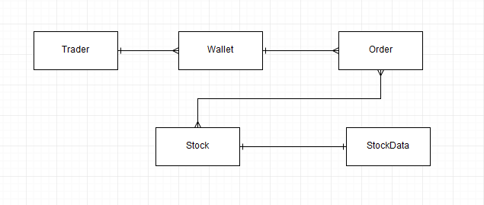

# Architectural Design

## Conceptual Architecture

For the purpose of this project I will use the Layer Architectural Pattern. If I were to use real-time data this would not be enough in itself, as I would need a mechanism to update my database every second. Thankfully, due to the nature of a simulator, I can use past prices of certain stocks which I will store in a database. The application will access, process and show that data to the user through a traditional 3 layer architecture:

**Data Access**

Pretty self-explanatory, this layer will have the responsibility of accessing data in our database. That can be anything ranging from prices for a certain stock and certain date, user wallet data, login information etc. This layer will mostly contain the above mentioned models and data access objects for each and every one of them.

**Business Logic**

Input validation will take place here so to make sure that the data going through fulfills our criterias.

**Presentation Layer**

The user interface will be built in this layer. Users will be able to buy/sell stocks with imaginary money. They will have the option to follow price charts and export reports which detail their balance changes over the past x days.

**MVC**

To complement the Layered Architecture I will use the Model-View-Controller design pattern. This is composed of the 3 parts that give it’s name:

**Model –** Lowest level, responsible for data maintenance.

**View –** Responsible for displaying data on a user interface

**Controller –** Controls interactions of the above two.

## Package Design

## Component and Deployment Diagrams

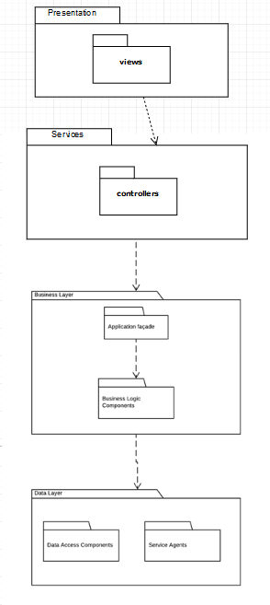

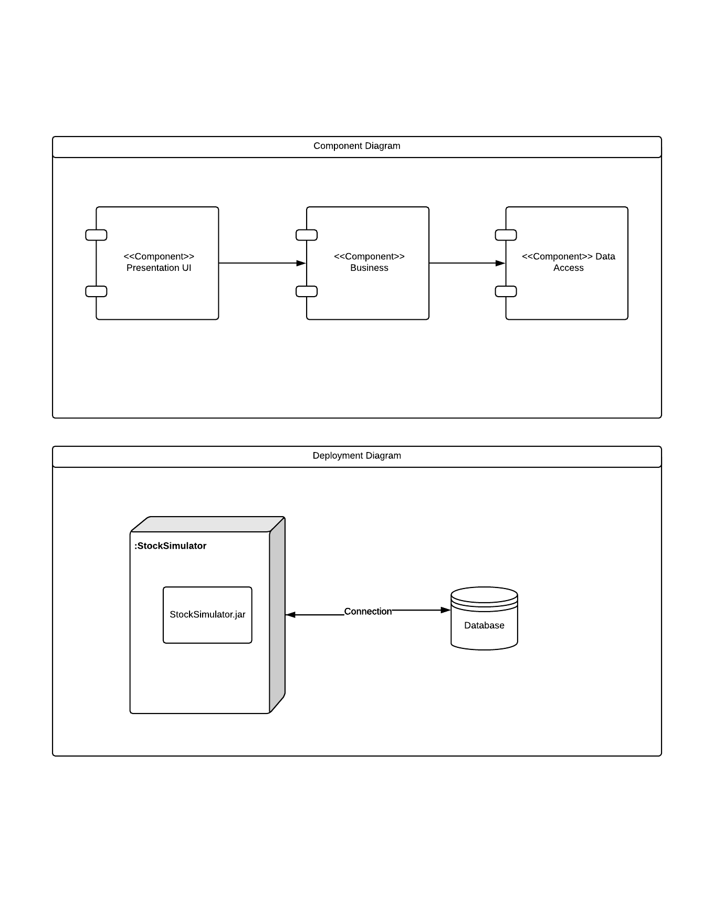

# Elaboration – Iteration 1.2

# Design Model

## Dynamic Behavior

*[Create the interaction diagrams (1 sequence, 1 communication diagrams) for 2 relevant scenarios]*

## Class Design

*[Create the UML class diagram; apply GoF patterns and motivate your choice]*

# Data Model

*[Create the data model for the system.]*

# Unit Testing

*[Present the used testing methods and the associated test case scenarios.]*

# Elaboration – Iteration 2

# Architectural Design Refinement

*[Refine the architectural design: conceptual architecture, package design (consider package design principles), component and deployment diagrams. Motivate the changes that have been made.]*

# Design Model Refinement

## *[Refine the UML class diagram by applying class design principles and GRASP; motivate your choices. Deliver the updated class diagrams.]*

# Construction and Transition

# System Testing

*[Describe how you applied integration testing and present the associated test case scenarios.]*

# Future improvements

*[Present future improvements for the system]*

# Bibliography